go run ./ycsb -dist zipfian -records 1000000 -txcount 500000 -skew 0.1 -goroutines 20
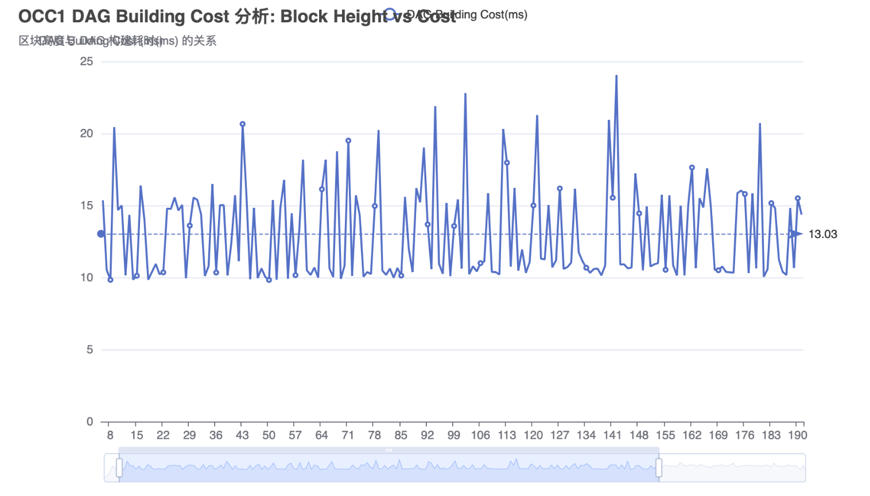
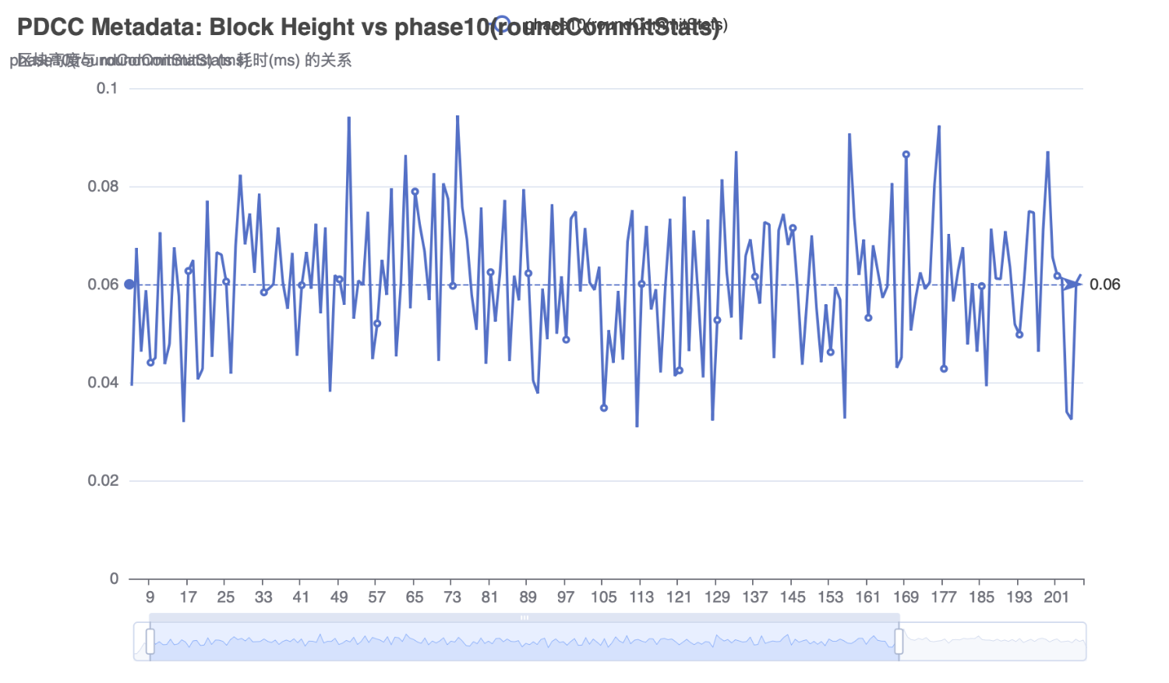

go run ./ycsb -dist zipfian -records 1000000 -txcount 500000 -skew 0.3 -goroutines 20
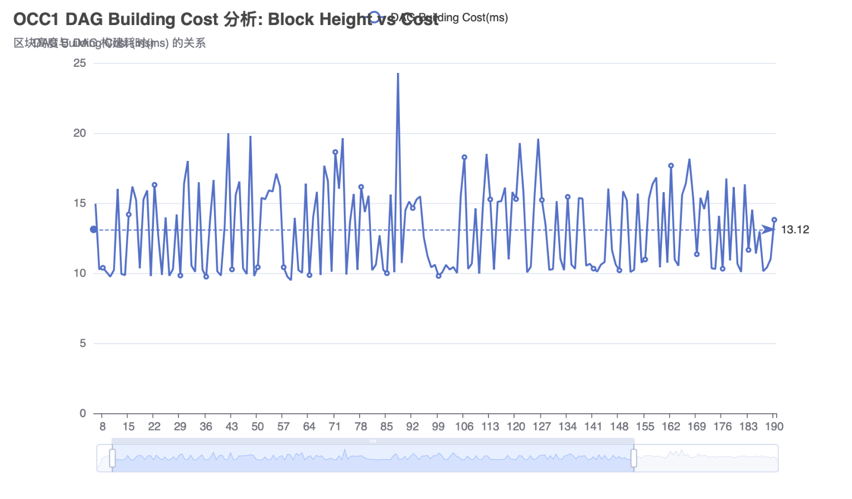
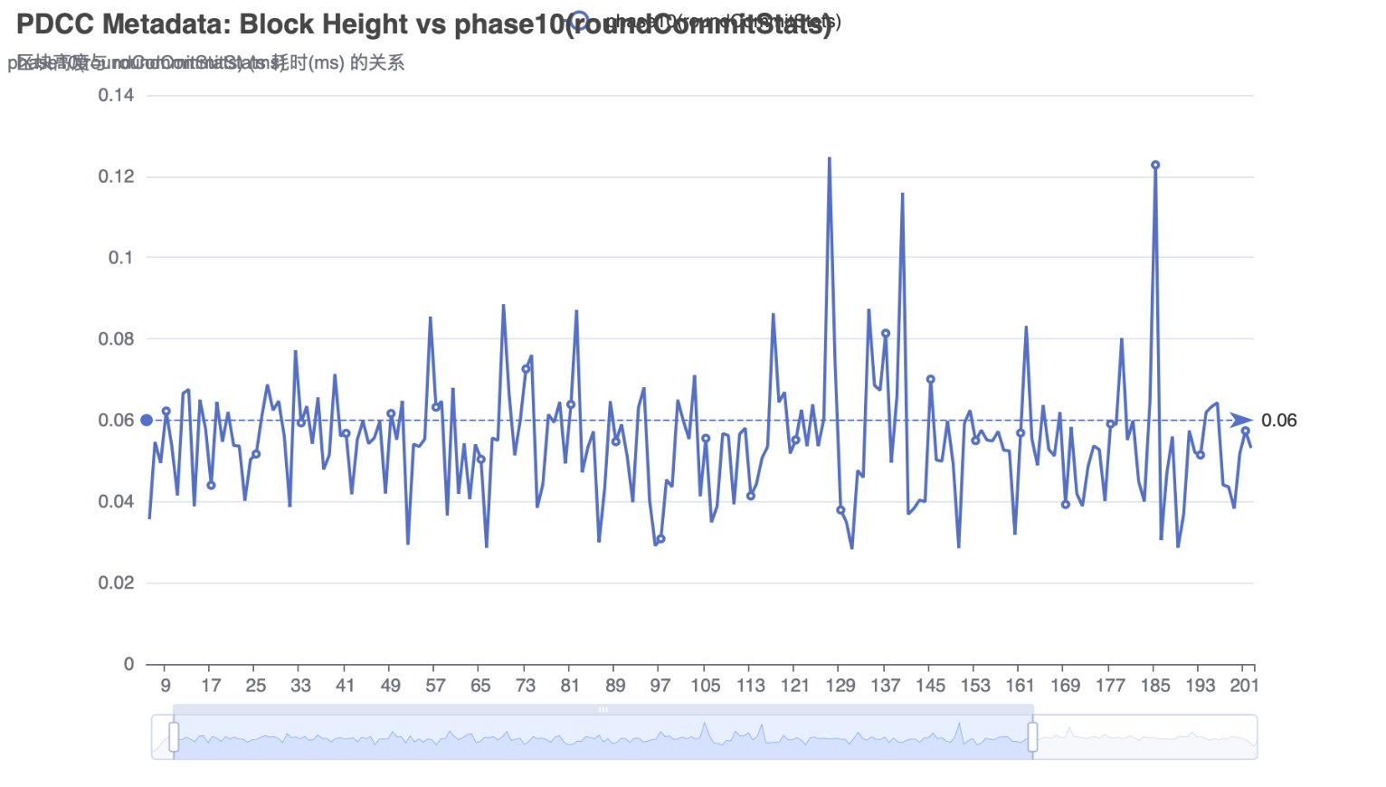
go run ./ycsb -dist zipfian -records 1000000 -txcount 500000 -skew 0.5 -goroutines 20
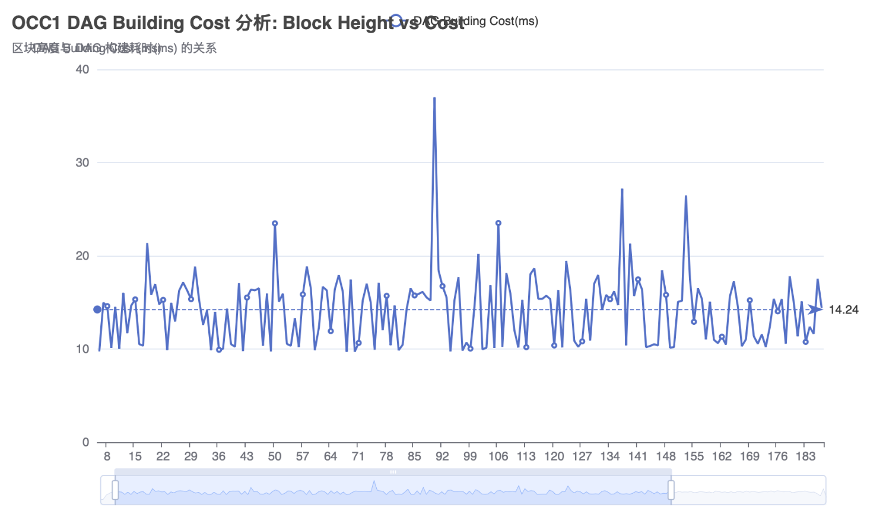
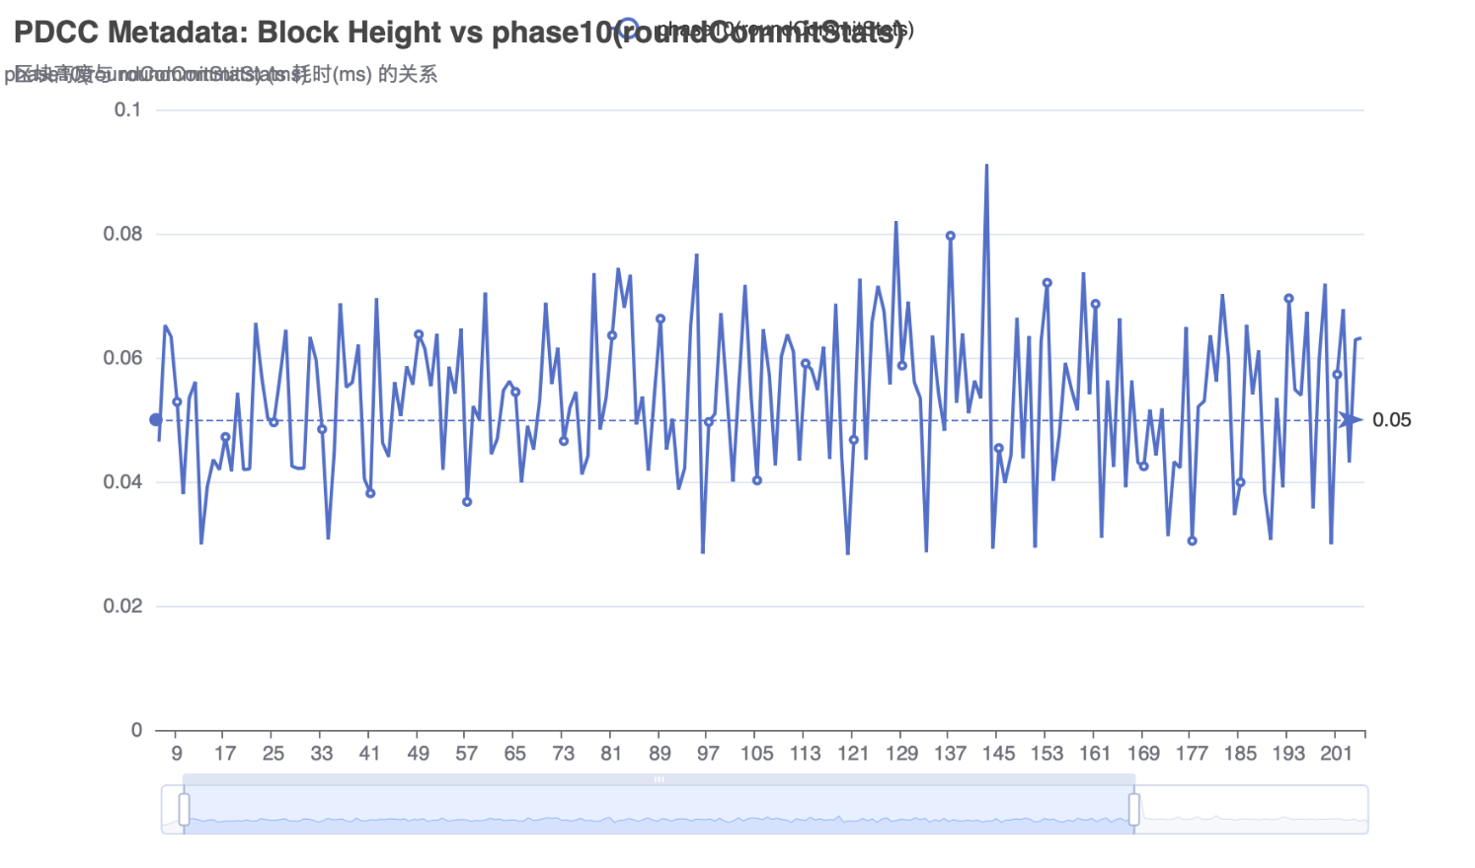

go run ./ycsb -dist zipfian -records 1000000 -txcount 500000 -skew 0.7 -goroutines 20
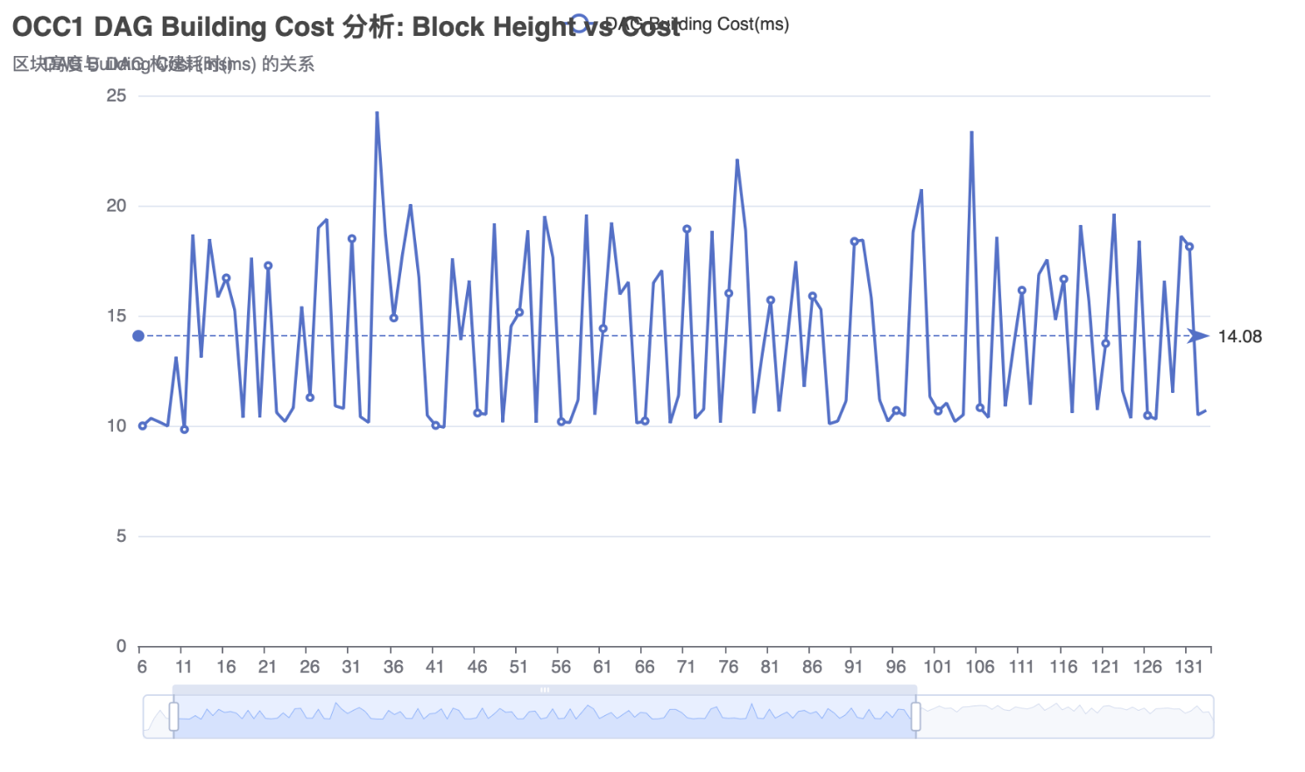
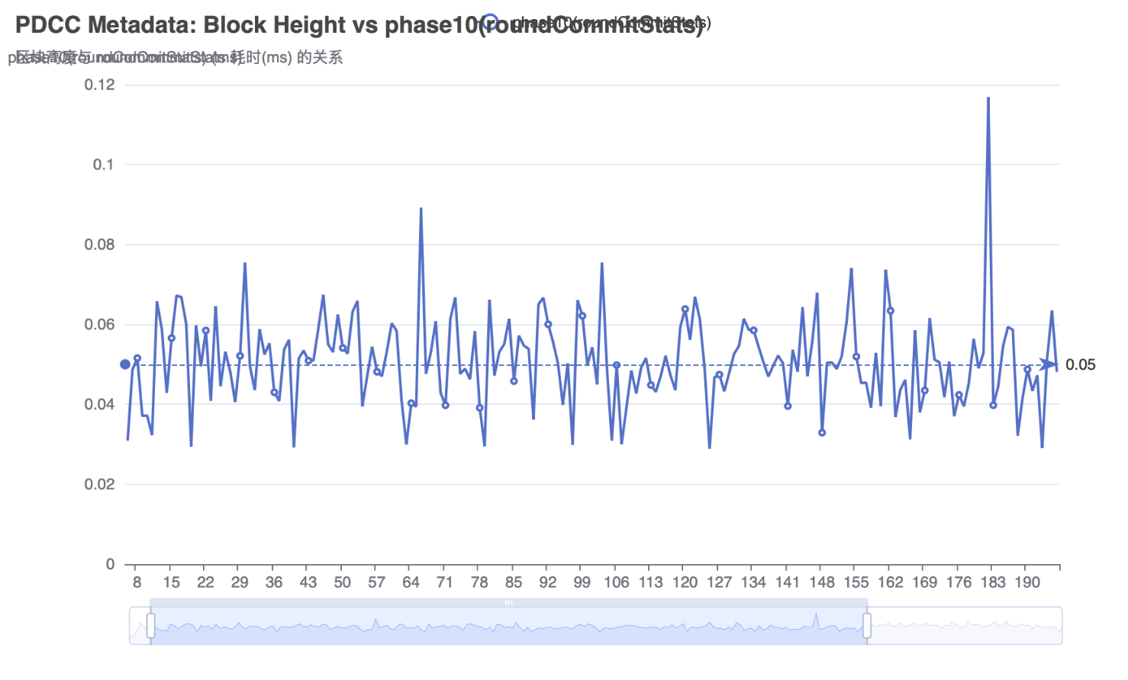

go run ./ycsb -dist zipfian -records 1000000 -txcount 500000 -skew 0.9 -goroutines 20
